PREP SCHOOL SCIENCE TEACHER

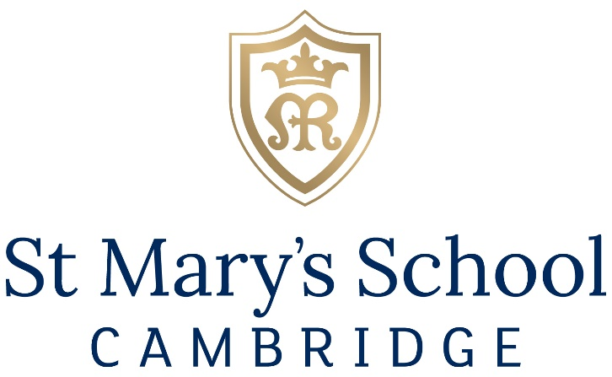

SEPTEMBER 2024

St Mary’s School
Bateman Street
Cambridge
CB2 1LY

T: 01223 353253
F: 01223 280254

hr@stmaryscambridge.co.uk

St Mary’s School Cambridge – A Company Limited by Guarantee. Registered Office: Bateman Street Cambridge CB2 1LY –
No. 184031 England Registered Charity No. 290180

Welcome from the Head
Thank you for showing interest in this role at St Mary’s School, Cambridge.
We are an independent day and boarding school for girls aged 3 to 18. We have a school roll of over 600 students. Approximately 10% of the students are boarders. Reflecting the cosmopolitan community of Cambridge, on average 25% of students originate from overseas, from 30 countries.
The School offers a secure and welcoming learning environment for girls: we are delightfully situated in the heart of the academically renowned and culturally vibrant city of Cambridge. The Junior School is adjacent to the famous backdrop of Coe Fen, and the Senior School and Boarding House overlook the University of Cambridge Botanic Gardens.
Cambridge is an outstanding place to live and work. As a university city, Cambridge has the cultural advantages of a much larger settlement but with a population of approximately 145,000, it is a safe, clean and attractive location. The city has an international reputation owing to its world ranking university and the school benefits from its proximity to the digital and enterprise communities in the various high-tech science parks and enterprise hubs. We are within easy travelling distance of London, less than an hour by train and a short hop from London Stansted Airport.
There has been major investment in new facilities at the School over the past decade: a new Junior School; a new Sixth Form Centre; new provision of Art & Photography; the creation of our Science Hub; and our new boarding facility, Mary Ward House. We have developed our sporting facilities through an ambitious collaboration with Homerton College, University of Cambridge and have invested in a new boat house in a joint partnership with City of Cambridge Rowing Club and Homerton College. We are proud to be opening our Mary Ward Educational Suite in January 2024 which will provide new state of the art teaching spaces.
High quality facilities are only as good as the people who work in them, so we invest heavily in our staff, who we know are our greatest asset. We encourage staff to develop themselves through training and facilitate bespoke CPD opportunities for all.
St Mary’s School promotes equal opportunity for all staff and pupils and is committed to its culture of diversity and inclusion. We encourage applications from candidates from a wide range of backgrounds.
Above all, St Mary’s School, Cambridge is a very happy place. We have an excellent local reputation for being very friendly and nurturing, and yet ambitious, for the young women in our care, enabling strong progress to next steps at university, the world of work or a gap year. Our girls are genuinely delightful, the teachers and support staff are exceptionally dedicated; we are a very close-knit, loving, joyful and purposeful community.
St Mary’s really is a warm and welcoming environment for all staff, whatever their role, and we look forward to receiving your application.
Charlotte Avery

The St Mary’s Approach
We are proud to be a Christian school in the Catholic tradition and founded on the principles of our 17th century foundress, Mary Ward, our vision is that ‘By God’s grace, women in time will do much’ (Mary Ward 1585-1645). The challenge for women is not over, and whilst there are now more opportunities for 'women to do much' there are still considerable barriers and so our work continues via our mission to develop curious, creative and compassionate young women with the aspiration, confidence and integrity to shape a better world for the common good. Our approach is based on the core values of Freedom, Joy, Justice, Love and Truth and we live these values in school through our HEART habits of
H – Hard work We show perseverance and sustain focus.
E – Empathy We are kind, joyful, generous, value friendship and celebrate diversity.
A – Adaptability We adjust to difficult situations, are open minded, discerning and take calculated risks.
R – Responsibility We act justly and strive to uphold truth and lead by example.
T – Thoughtfulness We are creative, reflective, attentive, show gratitude, hear others and disagree well.
Our unique approach to education fosters a love of life and of learning, while growing the academic curiosity and spiritual wellbeing of each individual girl so that they can look beyond themselves and enter adulthood aspiring to be more and to give more, not just to have more. We warmly welcome girls, and staff, of all Christian denominations and other faith and secular backgrounds to join our thriving community.
This year the school celebrates its 125th anniversary. Building on our 400-year tradition, St Mary’s School, Cambridge belongs to an international network of approximately two hundred Mary Ward schools.
Innovative Learning at St Mary’s
We empower all our students to aim high. As an accredited High Performance Learning World Class School there has never been a more exciting time to join our team.
High Performance Learning (HPL) is a research-based, pedagogy-led philosophy that responds to our growing understanding of human capability. It sees all students as potential high performers who are not limited by ‘ability’. HPL makes the goal of high performance the expectation for all students and uses a unique teaching and learning framework to systematically grow minds and develop the cognitive skills, values, attitudes and attributes needed to reach success.
Here at St Mary’s, we are proud to be developing our own approach to HPL and welcome applications from like-minded colleagues who are ambitious for their students and committed to research-based approaches to teaching and learning.
For further information please visit https://www.highperformancelearning.co.uk/
Digital St Mary’s
St Mary's is a digital school which supports the School in its goals through
- developing a community of staff and students which learns in, responds to and engages with an ever-changing digital world;
- preparing students for their future by giving them the confidence to work in a digital environment;
- establishing creative teaching and learning environments;
- employing teaching staff who are trained and supported to be technologically and digitally skilled.
All members of St Mary's work digitally using Microsoft 365 as a platform. All students in the Senior School and Sixth Form have access to an individual device (Microsoft Surface Pro) which are used in extensively in lessons and for home learning.
Job Description: PREP SCHOOL SCIENCE TEACHER
Reporting to: Deputy Head Learning & innovation (JS) & Heads of Science (SS)
Hours of Work: Full-time/Part-time (0.6 or above)
Salary: £30,965 - £43,671 FTE (dependent on experience)
Line Managing: Additional JS Science teachers

The primary aspect of the role will be teaching classes from Reception to Y6. The position also requires experience of upper KS2/KS3 Science. For a full-time candidate there is an expectation to teach KS3 Science at the Senior School in Years 7 to 9, and the opportunity to teach KS4 Science for the appropriate candidate.
The Junior School
St Mary’s Junior School has the capacity to educate 200 girls from ages 3 to 11. The school, which is set in leafy Cambridge on the edge of Vicars Brook and the Fen, combines a warm and nurturing environment with excellent resources, a commitment to teamwork and the professional development of staff. From here, many of our girls go on to join our successful Senior School on Bateman Street, where they remain until the end of Sixth Form.
St Mary’s is an ambitious school with a strong set of values focused on providing every girl with the opportunity to reach their full potential. Nurturing a love of learning, we ensure that each child acquires and secures the skills to become effective lifelong learners, fit not only for the world we live in today, but for a future yet to be determined. Adventure, curiosity, kindness and reflection lie at the core of what we do. Coupled with our strong and thriving connection with The Mary Ward values. We place equal importance on their social, moral and cultural growth. At all times the girls are expected to uphold the ethos of the school in a positive manner and are proud ambassadors; not only on site but when representing St Mary’s at outside events, activities and fixtures. We foster a desire to learn by offering a curriculum that has breadth, balance and challenge. Above all, we encourage academic endeavour and that each child strives, gives of their best, and achieves their potential.
At St Mary’s Junior School we maintain high expectations and place a strong emphasis on acknowledging the positive ways in which the girls conduct themselves and interact with others. Trust, honesty, good manners, a hardworking attitude and respect for the environment and above all, each other, are intrinsic in all that we do. We place great emphasis on the strength of our community and the girls being considerate, courteous and tolerant of the needs of others.
We are a progressive and vibrant school that focuses on raising the aspirations and releasing the potential of every young person in our care. In this environment, they have the opportunity to grow academically, on the sports field, artistically, on stage, and to take leadership responsibilities in many different areas. Life at St Mary’s is a unique experience but one that is treasured by all in its community.
What we can offer you
- The opportunity to join a very successful team of committed and highly qualified teachers.
- A supportive environment where the work-life balance of teachers is important.
- Outstanding facilities and resources to support learning and teaching.
- A forward-thinking, can do, risk-taking, mistake celebrating community where anything is possible!
- An opportunity to grow as a leader and access further professional development opportunities both in the Junior School and within the wider St Mary’s community.
- A bespoke induction and training programme with built-in support and mentoring as required.
- A strong Staff Wellbeing Programme (wellbeing days/staff events/breakfasts/socials)
- The opportunity to be part of St Mary’s Junior School at this most pivotal and exciting time.

Senior School Science Department Summary
The ability to teach all, or most, of the three Sciences up to Key Stage 3 is desirable. A general interest in STEM subjects is essential.
You will work with a broad ability range of enthusiastic students in small classes who are a delight to teach. You should enjoy the challenge of teaching motivated and ambitious students and show a love for the subject which reaches beyond the classroom.
The Science Department is a central part of school life and has gained a reputation for academic excellence, with parents and students alike viewing science as a desirable career pathway. The department is superbly resourced with purpose-built laboratories to encourage and facilitate student enquiry and research. As such this is a fantastic opportunity for an aspiring, imaginative and inspirational teacher to join a creative and innovative environment. You will join and be supported by a successful Science faculty with exacting standards.
There are currently 10 full-time and 2 part-time teachers in the department and 3 highly experienced and dedicated technicians who manage well-resourced Science prep rooms and who contribute to the department’s success. Each lab is equipped with a PC, an interactive whiteboard and a ‘Genee Vision Visualiser’ (digital camera projector).
Chemistry, Biology and Physics are taught as separate subjects from Year 8 to A Level. At KS3, students follow an ‘in-house’ course that teaches the foundations of the subject. At KS4, the Edexcel IGCSE course is followed. At GCSE students can choose, with advice from their teachers, either the separate or the double award IGCSE route.
At A level the Chemistry and Biology departments follows the OCR A course and Physics the Edexcel course. All three subjects are popular options with students studying in classes of usually no more than 10. A high number of students go on to read a range of subjects at university from Physics and Engineering to Veterinary Science and Medicine. All members of the science faculty provide strong support and guidance to students for their university applications.
For further information, please do not hesitate to contact the Joint Heads of Science.
- Dr Crawshaw (JCrawshaw@stmaryscambridge.co.uk)
- Mrs A Chatterjee (AChatterjee@stmaryscambridge.co.uk)
- Mrs Egan-Smith (MEgan-Smith@stmaryscambridge.co.uk)
Key Responsibilities for a teacher (Junior School)
KEY AREAS | PROFESSIONAL DUTIES AND RESPONSIBILITIES
Leadership | - Lead the development of outstanding, innovative learning and teaching in the field of Science across the Junior School  - Ensure that inventive use is made of resources, including new technologies  - Ensure that the delivery of Science is exciting and stimulating and inspires girls learning  - Promote a strong and cohesive Science department and to devise and execute an inspiring development plan (updated annually) in accordance with strategic priorities  - Review, maintain and develop appropriate schemes of work for the department, be aware of developments in Science education and maintain a detailed knowledge of best practice  - Take responsibility for the administration of the department  - Develop and regularly review departmental policies  - Hold responsibility for Health and Safety within the Science laboratory  - Lead, promote and monitor extra-curricular activities and events related to Science  - Advise the Deputy Head (Learning & Innovation) about resources, curriculum changes and staff development  - Ensure the visual appearance of the department and classrooms are of a high standard  - Prepare the department for inspections  - Maintain the JS Department Handbook and write a yearly Development Plan which fits in to the school’s strategic plan  - Ensure all departmental information is kept up to date  - Make effective use of social media for Science, collaborating closely with the school’s Marketing and Communications professionals
Assessment, Review and Monitoring | - Monitor the department’s marking and coverage of schemes of work  - Ensure that each girl in the school is fulfilling her potential in Science  - Ensure school expectations with regards to prep, marking and data analysis are met within the department, track the progress of pupils and meet with colleagues as required  - Ensure that feedback genuinely moves learning forward  - Monitor, modify and evaluate the Schemes of Work on a regular basis  - Monitor feedback and marking, with regular work scrutiny  - Assist with and monitor short and medium term planning  - Devise appropriate forms of assessment, recording and reporting in accordance with whole school assessment policy and any statutory curriculum requirements  - Ensure continuity and progression between the year groups  - Plan, organise and evaluate the transfer of assessment information between year groups  - Participate in the on-going review of the curriculum  - Liaise closely with the Senior School to ensure academic continuity  - Monitor progress of report writing and take action to ensure deadlines are met
Parental Responsibilities | - Where appropriate, meet with parents to discuss their child’s academic progress  - Create opportunities to provide further information and guidance to parents regarding their child’s science education and progress  - Actively engage parents in the learning journey
Pastoral Care, Social Development & Safeguarding | - To inform the Head or DSL of any concerns you may have about any children  - To liaise with the DSL to ensure the safeguarding and security of all children in your care  - Promote and safeguard the welfare of pupils and adhere to and ensure compliance with the school’s Child Protection procedures and staff guidance at all times reporting any concerns to the DSL or Headteacher as appropriate  - Be aware of Health and Safety requirements, including where to obtain expert advice  - Communicate with the Health and Safety Team any Health and Safety issues regarding the welfare or safety of the pupils or staff  - Be familiar with the school’s fire safety procedures and participate in drills as required

Wider School Responsibilities | - Attend school events and actively consider ways in which to engage the parent body with their child’s learning  - Assist in the delivery of co-curricular offerings both in and out of school  - To participate in educational visits and extra-curricular activities  - To carry out other supervisory duties as required  - To participate in meetings, training and professional development as required  - To provide cover for colleagues as required  - To undertake such other reasonable duties that may be required from time to time

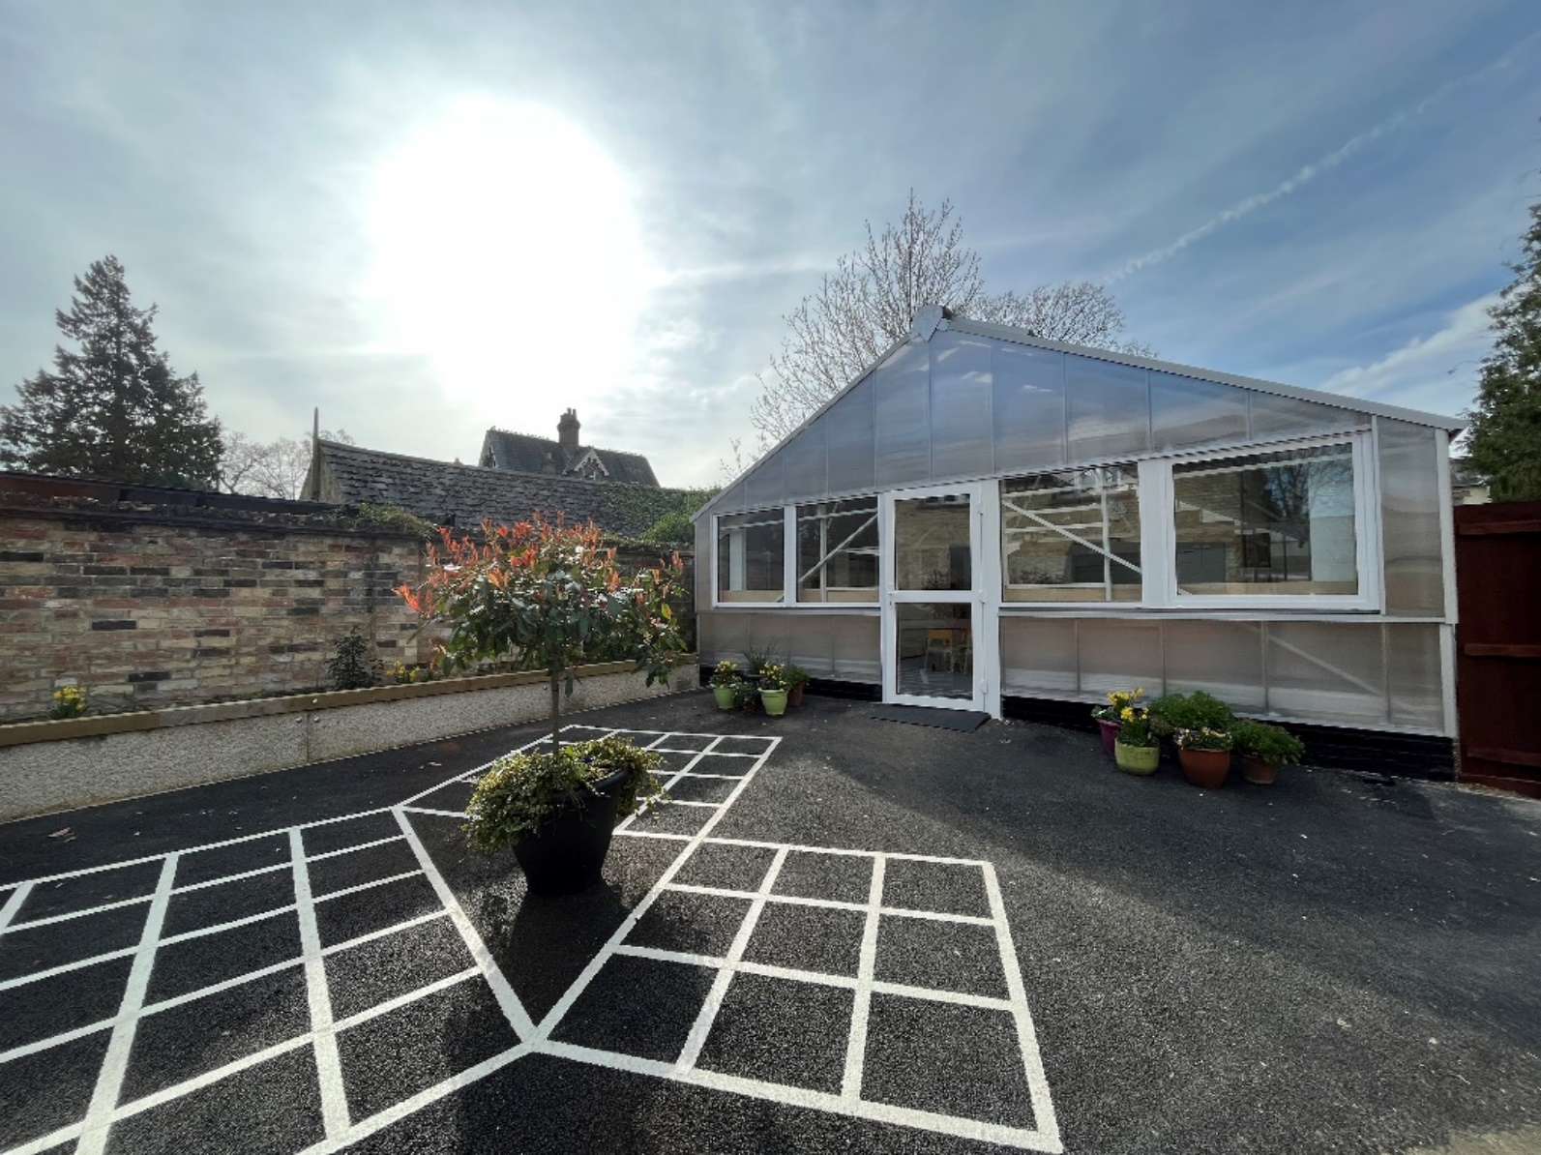

Key Responsibilities for a teacher (Senior School)
KEY AREAS | PROFESSIONAL DUTIES AND RESPONSIBILITIES
Teaching & Learning | - Planning and preparing courses and lessons  - Teaching, according to the needs of each student  - Assessing, recording and reporting on the development, progress and attainment of students  - Setting high educational standards for every student within the classroom  - Promotion of the general wellbeing of classes and the individual students within these  - Provision of specific subject related guidance and advice to students on further education and future careers, including information about sources of more expert advice on specific questions and university/work experience interview practice  - On school systems, keeping records of and writing reports on the academic progress and needs of students  - Ongoing self-review of your methods of teaching and programmes of work  - Where appropriate, moderation of non-examinable assessments, including Extended Project Qualification or other project based qualifications  - Setting of cover work when absent, when appropriate to do so
Safeguarding & Pastoral | - To promote and safeguard the welfare of students at all times  - To comply with the Safeguarding and Child Protection Policy of the School, and ensure that any concerns relating to the safety or welfare of children are reported to the appropriate person  - Maintaining good order and discipline among the students when they are engaged in authorised school activities elsewhere  - Maintaining student health and safety  - Liaising with the Head of Boarding, the Heads of Year, tutors and the nurses regarding the welfare of students  - Keeping records of and writing reports on the personal and social needs of students  - Tutor duties including one-to-one meetings with tutees, attendance at assemblies, registration of the attendance of students and supervision of their attendance, organising form prayers and delivery of PSHEE, whether these duties are to be performed before, during or after school sessions
Enrichment & Extra Curricular | - Participation in the enrichment programme as part of timetabled lessons  - Participation in the extra-curricular programme, both within the department and for the whole School, outside of timetabled lessons
Professional Responsibilities | - Adherence to the Staff Behaviour Policy of the School at all times  - Participation in an induction programme  - Attendance of all INSET meetings and completion of relevant training  - Communication and consultation with parents  - Communication and cooperation with persons or professional bodies outside the school  - Participation in meetings arranged for any of the purposes described above  - Attendance at Briefings, Parent Evenings, and Open Events, or any other events reasonably required by the School  - Participation in meetings at the school which relate to the curriculum for the school or the administration or organisation of the school, including pastoral arrangements  - Participation in reviews and appraisal of your performance and that of other teachers, where appropriate  - Participation in arrangements for further training and professional development including those aimed at meeting the needs identified in performance objectives or in appraisal statements  - Teachers will be required to be available for cover as indicated on the reserve list but also at other non-contact times as the need arises  - Assist with invigilation, as required  - Participation in administrative/organisational tasks related to duties around the school  - Other related duties as directed by Head, senior leaders or line-manager
Person Specification
SPECIFICATION | DETAIL
Qualifications | - Undergraduate Degree in relevant science area  - PGCE, QTS or equivalent essential  - Further professional qualifications associated with this role
Qualities and Attributes | - Commitment to academic excellence  - Ability to work effectively in a team  - Excellent organisational skills and attention to detail  - Ability to communicate articulately and confidently with all stakeholders  - High levels of personal and professional responsibility and integrity  - Resilient, flexible and responsive to challenge  - Prioritise deadlines and work under pressure  - Self-motivation, enthusiasm and approachability  - Good rapport with students, colleagues and parents  - Appropriate levels of personal presentation
Experience, Knowledge and Skills | - Excellent secondary school classroom practice  - Confident use of ICT  - Effective planning, teaching and class management  - Preparing and sharing teaching resources  - Motivating and inspiring students  - Creative and innovative in teaching and learning  - Commitment to improve, monitor and self-evaluate teaching and learning  - Involvement in all elements of school life including enrichment activities  - Commitment to best practice in pastoral support and student welfare  - Promotion of safety and wellbeing of students
Personal Values | - Commitment to the ethos of the school  - High expectations for student attainment and conduct  - Commitment to own personal development  - Commitment to a culture of continuous improvement  - Readiness to contribute to the whole school when required

Benefits
At St Mary’s you will enjoy an exceptional career and comprehensive benefits including a defined contribution workplace pension scheme offered through APTIS (Aviva Pensions Trust for Independent Schools) at a flexible employer contribution level up to 22%, BUPA cash plan, 33% discount (pro rata for part-time staff) on school fees, an occupational sickness scheme, free lunches and refreshments, a season ticket discount and much more.
Equality, Diversity and Inclusion
St Mary’s School is committed to ensuring equal opportunities in all aspects of employment and selects staff on merit irrespective of race, religion or belief, pregnancy and maternity, marital status, sex, sexuality/gender preference, disability or age. You are not obliged to complete the Equal Opportunities Form, but any information given will help us monitor the effectiveness of our policies and procedures.
If you have a disability, you are invited to request any special arrangements that you may require for interview or any adjustments that you would consider necessary to your working arrangements by contacting our Human Resources department (hr@stmaryscambridge.co.uk, 01223 353253).

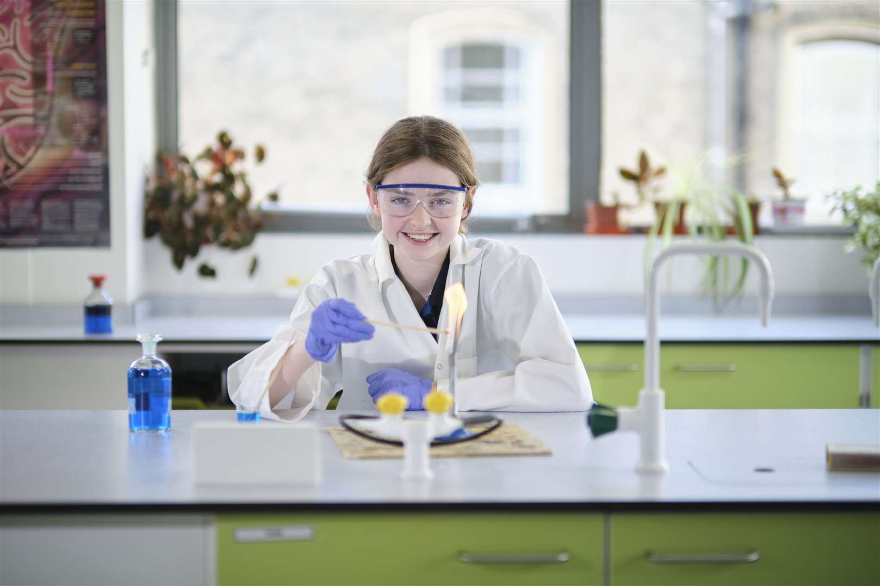
Process
Application is welcomed by completing the Application Form and Equal Opportunities Form which can be found on the Vacancies page of our website. This may be accompanied by a covering letter and a curriculum vitae. We are unable to accept applications supported by a CV alone.
Interviews will be conducted in person, and they will explore candidates’ suitability to work with children. Candidates are required to bring with them the necessary ID documentation and any relevant qualification certificate(s), all of which must be originals. Further information of the interview format will be provided if you are shortlisted for interview.
If you have any question, please contact the HR Team by email: hr@stmaryscambridge.co.uk or call: 01223 353253.
Closing date: 8.00am Tuesday 14th May 2024
Interview date: from 8.00am Monday 20th May 2024
We will review applications on receipt. Suitable candidates may be interviewed before the closing date, and we reserve the right to withdraw the position if an early appointment is made.
Child Welfare and Child Protection Issues
The interview for this post will include exploring issues relating to safeguarding and promoting the welfare of children including:
- motivation to work with children and young people;
- ability to form and maintain appropriate relationships with children and young people;
- emotional resilience in working with challenging behaviours;
- attitudes to the use of authority and maintaining discipline.
Any relevant issues arising from the take up of references will be discussed at interview. The school is an equal opportunities employer. We are committed to safeguarding and promoting the welfare of children and young people and expect all staff and volunteers to share this commitment. Successful applicants are subject to an Enhanced Disclosure and Barring Check.

